**TX HCSC CAV Reports**

**Objective: Select monthly records marked as 110’s from fusp delivered to client to create text file for Account Management.**

**Report due to Account Management on 10th of each month.**

**Applications/Software**

* Microsoft Access
* DB2 database - ECPROD
* ODBC

**Database location:** **\\hmsfs.hms.hmsy.com\hmsdalfile_TPL\Cost Avoidance\CAV Client Services and Yield\TX HCSC CAV Report**

**Clients:**

* 842 – El_Paso
* 607 – BCB – Excludes RX claims delivered to client

Report criteria: Previous month 110’s delivered to client from fusp.

Example: When running report in April sqryTX_HCSC query is set to select the report date range of March 1 – March 31.

**Open TX HCSC CAV Report database.**

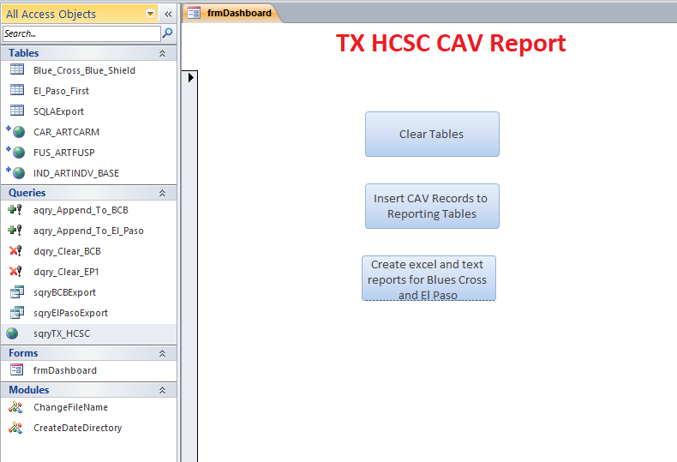

1. **Click button –** 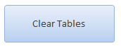

**This will clear tables:**

* Blue_Cross_Blue_Shield
* EL_Paso_First

1. **Click button -** 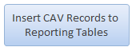

Log into DB2 database with you userid and password. Click ok.

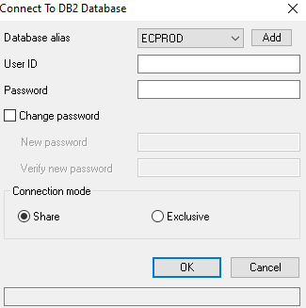

This will import data from fusp of 110 delivered records from previous month into tables based on client_cd

* Blue_Cross_Blue_Shield
* EL_Paso_First

You can check data by double clicking tables to view data.

Once you view data and confirm tables are populated you can proceed to next step.

If no results reach out to analyst.

1. **Click button -** 

This will first create a folder in directory using naming convention “yyyymmdd” using date the file is created.

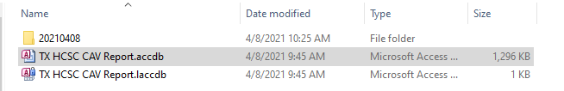

**\\hmsfs.hms.hmsy.com\hmsdalfile_TPL\Cost Avoidance\CAV Client Services and Yield\TX HCSC CAV Report**

Next the two pipe delimited text files will be created for both clients.

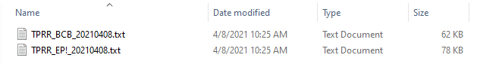

1. Review text files and confirm they are pipe delimited.
2. Email the text files to Rachel Kik & Camille Barnes

Example of email.

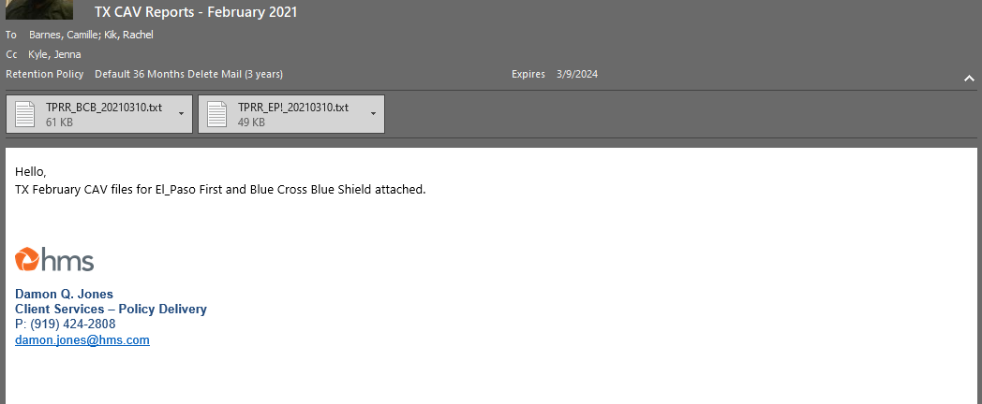

**SQL**

--TX HCSC CAV Report

--Client Code 842 El Paso

--Client Code 607 Blue Cross Blue Shield

SELECT Distinct

I.MA2_NUM AS "Client Patient Control Number",

F.RECIP_MA_NUM,

F.Recip_First_Nm AS "Client First Name",

F.RECIP_LAST_NM AS "Client Last Name",

C.CARRIER_NM AS "Insurance Company Name",

F.POLICY_NUM AS "Subscriber Number",

COALESCE (F.GROUP_NUM, '', F.ORIG_GROUP_NUM) AS "Group Number",

F.PH_FIRST_NM AS "Subscriber First Name",

F.PH_LAST_NM AS "Subscriber Last Name",

F.PH_SSN_NUM AS "Subscriber SSN",

--Populates with states relationship code

CASE When F.Rshcd_Rf = '03' Then 'C'

When F.Rshcd_Rf = '02' Then 'M'

When F.Rshcd_Rf = '09' Then 'O'

When F.Rshcd_Rf = '01' Then 'S' End As Relationship,

--Populates with states coverage type code

Case When F.Client_Cd = '842' and F.Plctp_Rf = 'MHOnly' Then 'B'

When F.Client_Cd = '842' and F.Plctp_Rf In ('EPO','HMO','HSA','MCMCO','OTH','POS','PPO') Then 'C'

When F.Client_Cd = '842' and F.Plctp_Rf = 'RXOnly' Then 'K'

When F.Client_Cd = '607' and F.Plctp_Rf = 'HMO' Then 'X'

When F.Client_Cd = '607' and F.Plctp_Rf In ('EPO','MHONLY','OTH','POS','PPO') Then 'Y' End AS "Type Of Coverage",

F.POLICY_START_DT AS "Coverage Start Date",

F.POLICY_END_DT AS "Coverage End Date",

F.EMP_NM AS "Employer/Union Name",

--Populates with identifier for source instead of client code

Case When F.Client_Cd = '842' Then 'EP1'

When F.Client_Cd = '607' Then 'BCB' End As "Source Code"

FROM FUS.ARTFUSP F

LEFT JOIN CAR.ARTCARM_BASE C

ON F.CARRIER_CD = C.CARRIER_CD

AND F.CARRIER_OFFICE_CD = C.CARRIER_OFFICE_CD

LEFT JOIN IND.ARTINDV_BASE I

ON F.INDV_ID = I.INDV_ID AND F.CLIENT_CD = I.CLIENT_CD

--Select El Paso records delivered to client

WHERE (F.CLIENT_CD = '842'

AND F.VRFRV_RF = '110'

AND F.REPORT_DT >= DATE (CURRENT DATE - (DAY (CURRENT DATE) - 1) DAYS - 1 MONTH)

AND C.DEFAULT_IND = 'Y') OR

--Select BCBC Records excluding RX claims delivered to client.

(F.CLIENT_CD = '607' AND (F.Plctp_Rf) NOT IN ('RXONLY') AND F.VRFRV_RF = '110'

AND F.REPORT_DT >=

DATE (CURRENT DATE - (DAY (CURRENT DATE) - 1) DAYS - 1 MONTH)

AND C.DEFAULT_IND = 'Y')

WITH UR;